Your Unemployment Insurance Information Handbook
Arkansas Division of Workforce Services
January 2024
Unemployment Insurance Hotline 1-844-908-2178

An equal opportunity employer and proud partner of the American Job Center network

Table of Contents
SECTION 1: General Information 2
Purpose of the Unemployment Insurance Handbook 2
Contact Information 2
Language Assistance 3
Overview of the Unemployment Insurance (UI) Program 3
SECTION 2: Eligibility for UI Benefits 4
Qualifying for Benefits 4
Options for Receiving a Payment 5
Amount of UI Benefits 5
Waiting Week 6
Reporting Earnings Other Income or Deductions 6
Other Income or Deductions that Can Affect Unemployment Benefits 7
Filing Weekly Certifications 8
Work Search 8
SECTION 3: Fraud 10
Definition of Fraud 10
Examples of UI Fraud 10
Penalties for Fraud 10
What We Do to Stop UI Fraud 11
Unemployment Insurance Fraud and Identity Theft 11
SECTION 4: Appeal Rights 12
The Appeal Process 12
Appeal Tribunal 12
Board of Review 12
Arkansas Court of Appeals 13
Filing Continued Claims During Your Appeal 13
Appendix A: Legal Disclosures 14
Equal Opportunity Information 14
What to Do if You Experience Discrimination 14
Accommodations for Individuals with Disabilities 14
Your Privacy Matters to Us 14
Appendix B: Glossary 16

SECTION 1: General Information

Purpose of the Unemployment Insurance Handbook

The goal of this book is to give information about filing for unemployment benefits.

You must read and understand the information in this document. If you do not understand or you have questions, please contact our UI Hotline at 1-844-908-2178.

Contact Information

There are many ways to contact us:

Call Us
You can call us at 1-844-908-2178. The UI Hotline is available Monday through Friday, 8:00am – 3:30pm.

Go to our Website
To file a claim using EZARC, click here. https://www.ezarc.adws.arkansas.gov/home
To file your continued claim or change your payment option, click here.
https://www.arknet.arkansas.gov/login

For information about partner programs, click here.
https://dws.arkansas.gov/

Visit in Person
You may visit one of our Arkansas Workforce Centers. Click here for the locations of our Arkansas Workforce Centers.
https://dws.arkansas.gov/workforce-services/arkansas-workforce-centers/

You can also visit one of our mobile units locations and schedules are here.
https://dws.arkansas.gov/workforce-services/mobile-workforce-centers/mobile-workforce-centers-monthly-schedule/

Language Assistance
Free services are available to assist you if you do not speak English.

*** Servicios de Interpretación/Traducción disponibles por medio de su oficina local. -- Ewōr Jerbal in ukok ikijien jeje im kennaan ilo opij ko ijo kwoj pād ie. --- Các Dịch Vụ Thông Dịch/Phiên Dịch có sẵn qua văn phòng địa phương của quý vị. --- ຫ້ອງການປະຈໍ າທ້ອງຖິິ່ ນຂອງທິ່ານໃຫ້ບໍ ຣິ ການນາຍພາສາແລະການແປເອກະສານ --- Interpretation/Translation services available through your local office.***

Overview of the Unemployment Insurance (UI) Program
UI provides benefits to workers who lost their jobs through no fault of their own. This can include layoffs, plant closures, or lack of available work.
- Benefits are paid from an employer tax.

- UI benefits are income that must be reported on your state
and federal income tax.

- You can choose to have federal taxes withheld from your
benefits.

- Due to the Privacy Act, we cannot discuss your claim with
anyone but you. This includes family members.
We are here to assist you through your time unemployed. To make sure you are paid benefits in a timely manner, please:
- Provide correct information.
- Reply to requests for information right away.
- Meet all conditions to be eligible for benefits.
- Make sure your address and phone number are up to date.
Change of Address or Phone Number
If you move or change your phone number, let us know as soon as possible. Failure to notify our agency of your current contact information may result in a delay in payment of benefits. The easiest way to update your address or phone number is by calling the UI Hotline.

SECTION 2: Eligibility for UI Benefits

Qualifying for Benefits

Our agency will review your claim to determine if you qualify for benefits. We look at these three criteria:

How much did you work in the 12-18 months before filing your claim?
This period is your base period. These wages are reported by your employer through their taxes during this period. This will determine if you have enough wages to set up a claim and how much you could receive in benefits.

Why are you no longer working for your past employer?
The reason you are no longer working helps determine if you may receive benefits. Below are some examples of separation reasons and
if you could receive benefits based on these reasons or not.

You may receive benefits if you:

  - Were laid off or your hours were reduced by your employer.
  - Left your last job and can show it was for good cause related to the job (such as unsafe working conditions).
  - Are unemployed because you or your child were a victim of domestic violence, stalking, or sexual assault.

You may not receive benefits if you:

  - Left your job for personal reasons not related to work.
  - Were fired for misconduct.
  - Are not legally allowed to work in the United States.
  - Are self-employed.
  - Are currently receiving workers’ compensation.
  - Refusing to apply for or accept suitable work.
  - Refusing recall after being laid off.
  - Are on leave through the Family Medical Leave Act. You are not considered unemployed.

Are you able and available to work?
In order to receive benefits, you must be:
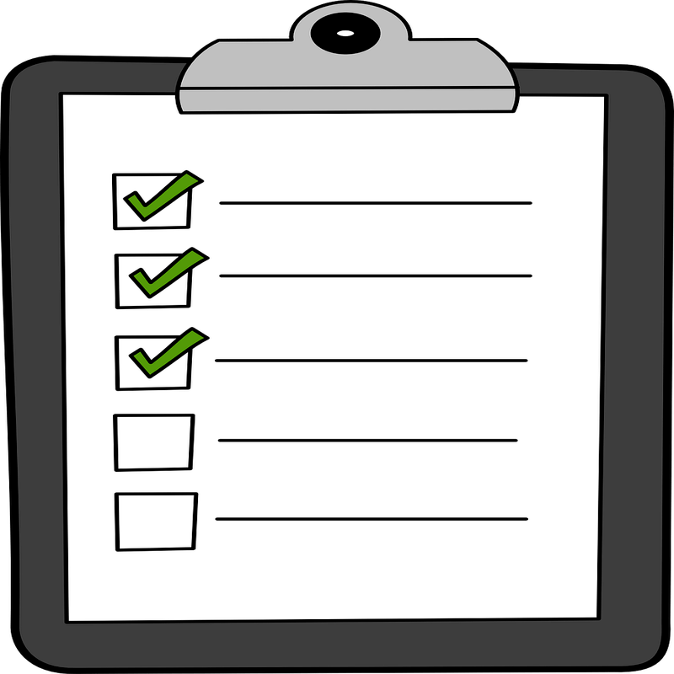
    - Looking for work.
    - Able to work. This means both mentally and physically.
    - Legally allowed to work in the United States.
    - Have no barriers that would prevent you from being able to begin work.

Options for Receiving a Payment
If you are eligible for UI benefits, you can be paid by:

Direct Deposit – Choose this method of payment and enter your bank account
information in ArkNet. Learn more about direct deposit here.
https://dws.arkansas.gov/wp-content/uploads/direct-deposit-brochure-2019.pdf
Debit Card – The US Bank Reliacard issued by ADWS. If you do not choose
direct deposit as your method of payment, a debit card will be issued to you.
Learn more about the debit card here.
https://dws.arkansas.gov/wp-content/uploads/ReliaCard_Visa_Flyer_2022.pdf

Amount of UI Benefits

After you file your claim for benefits, you will receive a Monetary Determination in the mail. This form explains:

- The amount of benefits you could receive, if approved. Your Weekly Benefit Amount is the amount you will receive each week. The Maximum Benefit Amount is the total amount of benefits on your claim.
- The number of weeks you will be eligible for benefits.
- Instructions on what to do if you disagree with the amount(s).

The highest weekly amount of benefits paid per week in the state of Arkansas is $451. You may qualify for up to 12 weeks per claim. The monetary determination will tell you how much you will get if approved in benefits and for how long.

When a claim is filed, a benefit year is established. This begins the first day of the first month of a quarter – no matter when the claim is filed, an runs for fifty-two (52) weeks.

Example: A claim filed on November 14 will have a benefit year that begins on October 1 of the same year and ends on September 30 of the following year.

If you have any questions about this form, please call the UI Hotline at 1-844-908-2178.

Waiting Week

The first eligible week on your claim is considered your waiting week. You must still meet the eligibility requirements for the week, but you will not be paid for this week. If you still meet the eligibility requirements for the next week, that should be when your payments will begin.

SUNDAY | MONDAY | TUESDAY | WEDNESDAY | THURSDAY | FRIDAY | SATURDAY
Week 1 | Claim Filed
Week 2

Example – John lost his job on Monday. He filed his intiial claim for UI benefits the same day. Even though John submits a weekly certification for the first week of benefits (Week 1), he will not be paid for this waiting week.

The next week (Week 2), if John is eligible, he will receive a payment.

Reporting Earnings Other Income or Deductions
If you are working while claiming UI benefits, you must report how much money you made. The amount you must report is your gross earnings for the work performed during the week you are claiming.

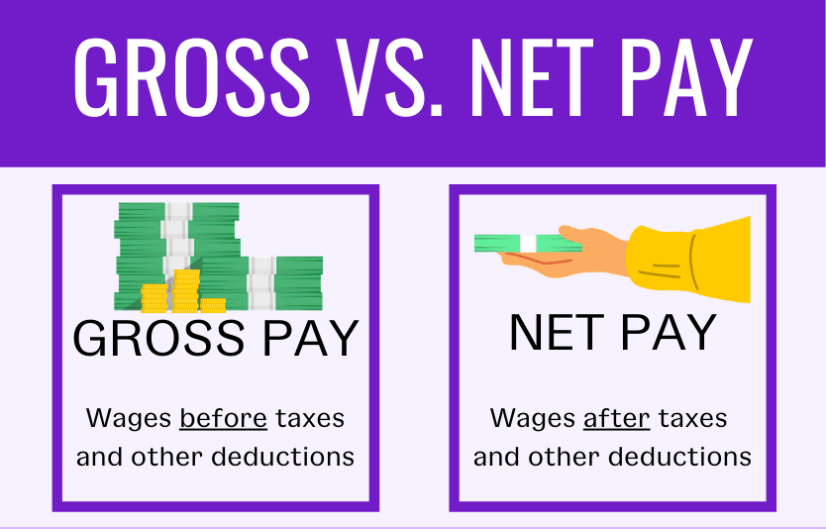

Weeks begin on Sunday and end on Saturday for unemployment purposes. You must keep up with your work and earnings in this way.

Example:

Sunday | Monday | Tuesday | Wednesday | Thursday | Friday | Saturday | Total Hours
X | 8 | 4 | 4 | 0 | 0 | X | 16

Week 1 – 16 hours worked X hourly rate = Gross Earnings for Week 1

Other Income or Deductions that Can Affect Unemployment Benefits

Other types of income can affect your benefits. Also, there may be deductions from your benefits which may keep you from getting your full weekly amount.

Separation Pay – Severance pay, pay in lieu of notice, or continuing to be paid by an
employer may affect benefits. Be sure to report any of this pay when filing for benefits or
by calling the UI Hotline.

Retirement Income – Retirement pay received from an employer in the base period may
affect your benefits. Be sure to report any retirement pay when filing for benefits or by
calling the UI Hotline.

Commission Sales – If you know the amount of commission you will receive, you will
report it during the week that you earn it. If you do not know your amount of commission,
you can report it during the week it is received.

Military Drill – If you participate in military drill, you must report your gross earnings during
the week being claimed.

Holiday Pay – Report gross holiday pay during the week of the holiday.

Vacation Pay – Report gross vacation pay during the week you took your vacation –
regardless of when you receive the payment from your employer.

Sick Pay – Report gross sick pay during the week you were off of work on sick leave –
regardless of when you receive the payment from your employer.

Paid Time Off (PTO) – Report gross PTO during the week you were off of work – regardless of when
you receive the payment from your employer.

Bonus Pay – Report gross bonus pay during the week it is received.

If you fail to report your earnings correctly to obtain more benefits it is considered fraud. There are severe penalties for fraud.
Your benefits may be reduced for:
Money Owed – Some or all your unemployment benefits may be reduced if you:

Owe child support.
Previously received UI benefits that you were not entitled to and did not repay them.
Taxes – Your benefits are taxable by the federal government and state government. You may choose to have federal taxes withheld at a rate of 10% from your weekly benefit amount.
If you do not have federal taxes withheld, you will be responsible for the full taxable amount at the end of the year.

By the end of January, ADWS will provide you with the IRS form 1099-G. This form shows the amount of benefits you were paid the previous year and the amount of taxes withheld if you selected that option.

Filing Weekly Certifications

After you file for benefits, you must file weekly certifications. This is to receive credit each week. You can do so by using one of the methods below:

ArkNet – ArkNet is the online service that allows you to file weekly certifications, change
your payment option and check the status of your claim. ArkNet can be accessed at
www.arknet.arkansas.gov and is available on Sunday from 12:01am through 6:00pm and
Monday through Friday from 6:00am until 6:00

ArkLine – ArkLine is the way to file weekly certifications by phone, change your PIN, and access unemployment insurance information. You can reach ArkLine by calling 1-501-907-2590. ArkLine is available on Sunday from 12:01am through 6:00 pm and Monday through Friday from 6:00am until 6:00 pm.

Work Search

You are required to actively search for work every week you receive UI benefits by completing at least five (5) of the work search activities in any combination listed below. These activities must be logged and kept for possible audit requirements.

Qualifying Work Search Activities
Apply for a job that fits your skills and abilities.
Interview for a job.
Attend a job fair. (one job fair counts as one work search activity, and no more
than one job fair can be claimed in one week)
Attend a job skill training at an Arkansas Workforce Center.
Attend a training with an approved training provider for an occupation that is in
demand.

If you belong to a union, will return to full-time work, or start full-time work in ten (10) weeks, or are on jury duty, call the UI Hotline.
Full-time Work: After you start a new full-tme job, you do not need to notify our office that you found work. Simply stop filing your weekly certifications when you start your new job (even if you will not be paid for a week or more.) Should you start a new job in the middle of the week, be sure to report your gross earnings for your new job when you claim that final week.
Part-time Work: If you find part-time work, you may still be eligible for partial UI benefit payments. Be sure to report any gross earnings from that part-time work.

SECTION 3: Fraud

Definition of Fraud

Fraud is not giving correct facts on purpose to obtain benefits. Fraud is a crime with severe penalties. You could also be subject to criminal prosecution.

Finding and stopping fraud is important to ADWS. Claims are reviewed regularly to check for fraud.

Examples of UI Fraud

- Not reporting money earned while claiming benefits.
- Not telling the truth about why you are no longer working for the last employer on your claim.
- Saying that you are able and available to work when you are not.
- Having someone else file your weekly certifications.
- Reporting that you looked for work when you did not.

The most important thing is to be honest – lying makes you guilty of fraud. If you are confused about what you are supposed to do or report, call the UI Hotline at 1-844-908-2178. We are here to help!

Penalties for Fraud

If you make false statements on purpose to gain or maintain benefits, this is fraud. You will:
- Pay back all UI benefits that you should not have received plus penalty and interest.
- Not be able to receive future benefits until the fraud disqualification period has been satisfied.
- Not be able to receive benefits for ten (10) years if you received $1,000 or more in benefits due to your fraud.
- Being charged with a crime in state and/or federal court.

What We Do to Stop UI Fraud

These are just some of the ways we identify fraud:
- Comparing earnings reported by workers and their employers.
- Checking state and national new hire databases.
- Checking job contacts.
- Leads from the public.
- Checking inmate rosters.
Report Suspected Fraud
You can report suspected fraud:
- Online here.
  - https://dws.arkansas.gov/workforce-services/unemployment/report-ui-fraud/
- Call the Fraud Hotline at 1-501-682-1058.

Unemployment Insurance Fraud and Identity Theft

If you believe someone has filed unemployment insurance in your name, you need to report it immediately. Click here to complete the form to report identity theft. https://dws.arkansas.gov/workforce-services/unemployment/reporting-ui-fraud/

More information and ways to contact our Fraud Unit can be found here.
https://dws.arkansas.gov/wp-content/uploads/Be_Aware_UI_Fraud_Info_6.12.23.pdf

You will be asked to provide a police report if your identity has been stolen.

SECTION 4: Appeal Rights

The Appeal Process

If you or your employer disagree with a decision regarding your UI claim, you each have the right to appeal. Appeals bring your claim to another authority to review. Once reviewed, the appellate body will decide if the decision remains or if changes are needed.

Appeal Tribunal

The Appeal Tribunal is the first level of appeals once DWS makes their decision. You have twenty (20) days from the mailing date of the decision letter, known as the Notice of Agency Determination, to submit your appeal to the Appeal Tribunal. You can submit an appeal by:
Mail – Download a copy of the Petition for Appeal to the Appeal Tribunal, found here or write a letter explaining why you disagree with the decision and send with a copy of the
Notice of Agency Determination to:
Arkansas Appeal Tribunal
P.O. Box 8013
Little Rock, AR 72203
https://dws.arkansas.gov/wp-content/uploads/ARK-AT-213_PETITION_FOR_APPEAL_L-static.pdf
Email – Send all forms to ADWS.UI.Hotline@arkansas.gov.

Arkansas Workforce Center – You can drop off all forms to any Arkansas Workforce Center. Click here for the locations of our Arkansas Workforce Centers.
https://dws.arkansas.gov/workforce-services/arkansas-workforce-centers/
Any inquires about a pending appeal can be directed to the Appeal Tribunal at 501-682-1063.

Board of Review

Once the Appeal Tribunal has made its decision, and you or your employer disagrees with that decision, an appeal can be filed to the Board of Review. You have twenty (20) days from the mailing date of the Appeal Tribunal decision to submit your appeal to the Board of Review. You can submit an appeal by:
Mail – Download a copy of the Petition for Appeal to the Board of Review, found here or
write a letter explaining why you disagree with the decision and send with a copy
of the Appeal Tribunal decision to:
Board of Review
P.O. Box 8016
Little Rock, AR 72203
https://dws.arkansas.gov/wp-content/uploads/ARK-BR-100-E_v09112019-static.pdf
Email – Send all forms to ADWS.UI.Hotline@arkansas.gov.

Arkansas Workforce Center – You can drop off all forms to any Arkansas Workforce Center. Click here for the locations of our Arkansas Workforce Centers.
https://dws.arkansas.gov/workforce-services/arkansas-workforce-centers/

Any inquiries about a pending appeal can be directed to the Board of Review at 501-683-4300.

Arkansas Court of Appeals

If you or your employer disagree with the decision made by the Board of Review, you can petition to the Arkansas Court of Appeals. You have thirty (30) days to file an appeal to the Arkansas Court of Appeals. You will have to file the Petition for Review to the Arkansas Court of Appeals yourself. You cannot submit this petition to DWS.

Mail your petition to:
Arkansas Court of Appeals
625 Marshall St. Suite 130
Little Rock, AR 72201

It is your responsibility to provide a copy of your petition to any opposing party, such as your employer.

Filing Continued Claims During Your Appeal

If you are still unemployed while going through the appeal process, it is important that you continue to file your weekly claims on ArkNet or ArkLine. You will still have to meet the eligibility requirements.

Appendix A: Legal Disclosures

Equal Opportunity Information
It is against the law for this agency to discriminate against any individual on the basis of race, color, religion, sex, national origin, age, disability, or political affiliation or belief, or against any beneficiary of, applicant to, or participant in programs financially assisted under Title I of the Workforce Innovation and Opportunity Act (WIOA).

What to Do if You Experience Discrimination
If you think that you have been subjected to discrimination under a WIOA Title I–financially assisted program or activity, you may file a complaint within 180 days from the date of the alleged violation.

To File a Complaint Online
Visit: www.dol.gov/oasam/programs/crc/complaint.htm

To File a Complaint by Mail
Send information about your complaint to:
The Director - Civil Rights Center
U.S. Department of Labor
200 Constitution Avenue, NW, Room N-4123
Washington, DC 20210

Accommodations for Individuals with Disabilities
We will make accommodations to allow your participation in all UI programs, activities, and services. To request an accommodation for a disability, please contact us at 1-844-908-2178.

Your Privacy Matters to Us
We follow all state and federal laws that protect your private information. To help connect you with programs designed to get you back to work, we share some of your information with our partners at the Division of Workforce Services and they are not allowed to share it with anyone else. We give them your:
- Contact information
- Employment and job search history
- Demographics (such as age or gender)
Your previous employers and other state or local government agencies may release to our agency any information, including your Social Security number, required for the proper administration of your claim. We also use your Social Security number to report the amount of UI benefits you receive to the Internal Revenue Service (IRS) as taxable income.

Appendix B: Glossary

This section defines commonly used terms and acronyms.

Appeal – A process for requesting a formal review of a prior UI decision.

Base Period – The window of time used to determine UI benefit eligibility. At the time an initial claim is filed, the base period is the first four of the last five completed calendar quarters.

Benefit Year – Also referred to as a claim year. This is the 52-week period starting with the first day of the first month of the quarter in which the claim is filed.

Benefits – The money given to eligible individuals.

Claim – An application for UI benefits.

EZARC – The online system to file a claim for benefits in Arkansas.

Fraud – Not being truthful about facts on the claim to receive benefits.

Gross Earnings – The amount of money you are paid for work before taxes and deductions are taken out.

Maximum Benefit Amount (MBA) – The total amount of benefits you may receive during the benefit year.

Misconduct – Careless or deliberate behavior that results in being fired or suspended from your job.

Monetary Determination – A form mailed to you after you file an initial claim for benefits that explains how much you are eligible for, the Maximum Benefit Amount (MBA) and Weekly Benefit Amount (WBA), the Base Period and Base Period employer(s), and other details about the Benefit Year.

UI Hotline – The staff that are able to assist claimants and employers with questions about unemployment. The number for the UI Hotline is 1-844-908-2178.

Unemployment Insurance (UI) – the benefit program for workers who become unemployed through no fault of their own.

Weekly Benefit Amount (WBA) – The maximum amount of money you are eligible to draw per week without any deductions.

